GENETIC EVALUATION OF FLEECE SHEDDING RATE IN YEARLING MATERNAL COMPOSITE SHEEP

E.G. Smith¹, M.P. Kelly², J.R. Keiller³, D.J. Brown¹ and S.F. Walkom¹

¹Animal Genetic and Breeding Unit (AGBU), University of New England, Armidale, NSW, 2350 Australia
²Low Footprint Lamb, Croxton East, VIC, 3301, Australia
³Cashmore Nudies, Cashmore, VIC, 3305, Australia

SUMMARY
Fleece shedding is an increasingly important trait in Australian sheep, but its genetic expression can change throughout the shedding season. This study investigated genetic variation in fleece shedding trajectories using 19,866 records from 6,815 yearling maternal shedding composite sheep. Random regression models estimated genetic and permanent environmental variances, heritability and genetic correlations across time. Heritability increased from 0.41-0.47 during early recording (June-Sept) to 0.53-0.65 from November onwards. Genetic correlations decreased with increasing time intervals of recording, while the correlation between slope and intercept was 0.60. Around 93% of genetic variation in shedding was attributed to slope, suggesting that conventional univariate models may incompletely capture some of the variation in shedding rate. As shedding recording systems mature, adopting trajectory-based genetic evaluation could improve selection for animals that shed earlier and more completely.

INTRODUCTION
Fleece shedding is an increasingly important breeding objective in Australian sheep production systems, with around 20% of Australian sheep now hair sheep or animals exhibiting some degree of natural fleece shedding. However, sheep differ not only in the extent to which they shed but also in the rate at which it occurs throughout the season. While the overall extent of fleece shedding is highly heritable (~0.50), genetic correlations between shedding recorded at different times during the shedding season are less than one (0.69 to 0.96) (Smith et al., 2026), suggesting that different genetic factors may influence shedding over time. Selection for an increased rate of shedding could provide economic and welfare benefits in regions with a high risk of flystrike by reducing wool cover earlier in the season. This study aimed to use longitudinal fleece shedding records to determine whether genetic variance in shedding changes across the shedding season and whether animals can be selected to shed both more completely and more rapidly. Random regression models were used to estimate genetic parameters describing the overall level (intercept) and rate of shedding (slope), with estimated breeding values (EBVs) and progeny performance of leading sires.

MATERIALS AND METHODS
Shedding data. Fleece shedding records were collected from two flocks in Victoria, Australia, between 2015 and 2025. The flocks originated from a maternal composite base population, predominantly of Coopworth ancestry, with shedding introduced using Dorper and Wiltipoll sires. Fleece shedding was assessed visually using the 5-point scoring system, where scores represent the proportion of the body covered with wool. A score of 1 indicated complete shedding, scores 2 to 4 represented increasing wool coverage, and a score of 5 indicated complete wool coverage (Sheep Genetics 2025). Fleece shedding typically commences after the winter solstice and continues until late summer, and scores here were collected from late June to early March, with time modelled as days since the winter solstice (DSWS; 21 June = day 0). Records were approximately normally distributed across DSWS. The final dataset included 6,815 yearlings (11-24 months) with 19,866 records, with each animal contributing two to five records (mean = 2.93). The dataset included 205 sires with at least four progeny (max, 426; mean, 24).
Statistical analysis. A random regression model using Legendre polynomials was used to fit the systematic fixed effects, the fixed regression of standardised fleece shedding trajectory over time, additive genetic, permanent environmental and residual effects. The model takes the general form;
$$y_{itl}=F_{l}+ \sum_{m=0}^{q_{1}}{∅_{tm}}β_{jm }+ \sum_{m=0}^{q_{2}}{∅_{tm}a_{im}}+ \sum_{m=0}^{q_{3}}{{∅_{tm}pe}_{im}}+e_{itl},$$
where $y_{itl}$was the shedding record of the animal$i$ taken at the DSWS $t$ belonging to the $l$th fixed factor; $F_{l}$ represents the fixed effects that are independent of DSWS and include sex and contemporary group, which was a concatenation of year of birth, fleece of measurement, and management group (n= 72, min 89, max 1052, mean 254). $β_{jm}$are the mth fixed regression coefficients for the mean shedding curve; $a_{im}$ and ${pe}_{im}$ are the mth random regression coefficients of the additive genetic and permanent environmental effects, respectively, for the ith animal. In this model, these coefficients are assumed to follow $a \sim N\left(0, K_{a}⊗A\right)$ and $pe \sim N\left(0, K_{pe}⊗I\right)$, where $K_{a}$ and $K_{pe}$ are the covariance matrices among the additive genetic effects and permanent environmental effects, respectively; $A$is the additive genetic relationship matrix from pedigree; $I$ is the identity matrix and ⊗ is the Kronecker product. $∅_{tm}$ is the covariate of the mth Legendre polynomial at DSWS $t;$ $q_{1}$, $q_{2}$, and $q_{3}$ are the first-order Legendre polynomials for the fixed, additive and permanent environmental effects, respectively.$e_{itl}$ are residual effects assumed homogeneous and follow $e \sim N\left(0, R\right)$. Heterogeneous residual variance across DSWS was tested and found to not be significantly different from the homogeneous model. Analyses were carried out using the BLUPF90+ suite (Lourenco et al., 2022).
Genetic parameters and EBVs. Estimates of the additive genetic variance for fleece shedding at different DSWS were obtained using; ${\hat{σ}}_{at }^{2}=$ $t_{t} {\hat{K}}_{a} t_{t}^{'}$, where ${\hat{K}}_{a}$ is the estimated covariance matrix of random regression coefficients for the additive genetic effects and $t_{t}$ are the row vectors of Legendre covariates evaluated at DSWS $t$. Permanent environmental variances (${\hat{σ}}_{pe}^{2}$) were calculated similarly, replacing ${\hat{K}}_{a}$ with ${\hat{K}}_{pe}$. The heritability at DSWS $t$ was estimated as; ${\hat{h}}_{t}^{2}= \frac{ _{{\hat{σ}}_{at }^{2}}}{{{\hat{σ}}_{at }^{2} + {\hat{σ}}_{pet }^{2}+ {\hat{σ}}_{e}^{2} }_{ }} .$ Standard errors were estimated using a Taylor series expansion. The genetic correlations between shedding over DSWS were estimated using; ${\hat{r}}_{g}= \frac{{\hat{σ}}_{a(t, tx)}}{\sqrt{ _{{\hat{σ}}_{a(t) }^{2}} _{{\hat{σ}}_{a(tx) }^{2}}}}$, where ${\hat{σ}}_{a\left(t,tx\right)}$ is the estimate of the covariance of additive genetic effects between pairs of DSWS $t$ and $tx$; ${\hat{σ}}_{a(t)}^{2}$ and ${\hat{σ}}_{a(tx)}^{2}$ are the additive genetic variances at DSWS $t$ and $tx$, respectively. EBV for animal $i$were estimated at DSWS $t$from the regression coefficients using;${ EBV}_{it }= {{\hat{ u}}_{i} t}_{t}^{'},$ where ${\hat{u}}_{i}$ is a vector with the estimated breeding values for the regression coefficients defining the change in shedding for a given animal$i.$Eigenfunctions of the additive genetic covariance matrix were calculated by; $ψ_{t}= \sum_{d=0}^{q_{2}}{{(c_{ψ_{f}})}_{d}}t_{t},$ where ${(c_{ψ_{f}})}_{d}$ is the $d$th element of the $f$th eigenvector of ${\hat{K}}_{a}.$

RESULTS AND DISCUSSION
Genetic parameters. Genetic variance of fleece shedding (Table 1) varied over time, increasing from 0.33 predicted at the winter solstice (DSWS 1) to 0.69 at DSWS 250 (late February). This means there is substantially more genetic variation among animals later in the season. Permanent environmental variance was highest at the beginning and end of the shedding period (0.17 and 0.20 at DSWS 1 and 250, respectively) and lowest at DSWS 100 (0.13). Residual variance was estimated at 0.31. Heritability was lower during the early shedding period (late June to mid-September), ranging from 0.41 to 0.47, and increased from early November (DSWS 150) onwards, ranging from 0.53 to 0.65. This pattern is consistent with previous multivariate analyses, which found lower heritability during early shedding, potentially reflecting limited variation in phenotypic expression (Smith et al., 2026). Genetic correlations between DSWS ranged from 0.48 ±0.02 between DSWS 1 and 250 to 0.99 ±0.01 between adjacent DSWS (Figure 1a), with correlations generally decreasing as the interval between DSWS increased.

Table 1. Variance components (±SE) and heritability (h² ±SE) estimates for yearling fleece shedding predicted at six time points following the day since winter solstice (DSWS).

DSWS | $σ_{a}^{2}$ ±SE | $σ_{pe}^{2}$±SE | $σ_{p}^{2}$±SE | h² ±SE
1 | 0.33 ±0.014 | 0.17 ±0.008 | 0.81 ±0.016 | 0.41 ±0.012
50 | 0.34 ±0.012 | 0.14 ±0.006 | 0.79 ±0.015 | 0.43 ±0.011
100 | 0.40 ±0.013 | 0.13 ±0.006 | 0.84 ±0.015 | 0.47 ±0.010
150 | 0.51 ±0.015 | 0.14 ±0.006 | 0.96 ±0.017 | 0.53 ±0.0102
200 | 0.69 ±0.020 | 0.16 ±0.007 | 1.16 ±0.021 | 0.59 ±0.010
250 | 0.92 ±0.028 | 0.20 ±0.009 | 1.43 ±0.026 | 0.65 ±0.009
(additive, $σ_{a}^{2}$; permanent environmental, $σ_{pe}^{2}$; phenotypic $σ_{p}^{2}$)
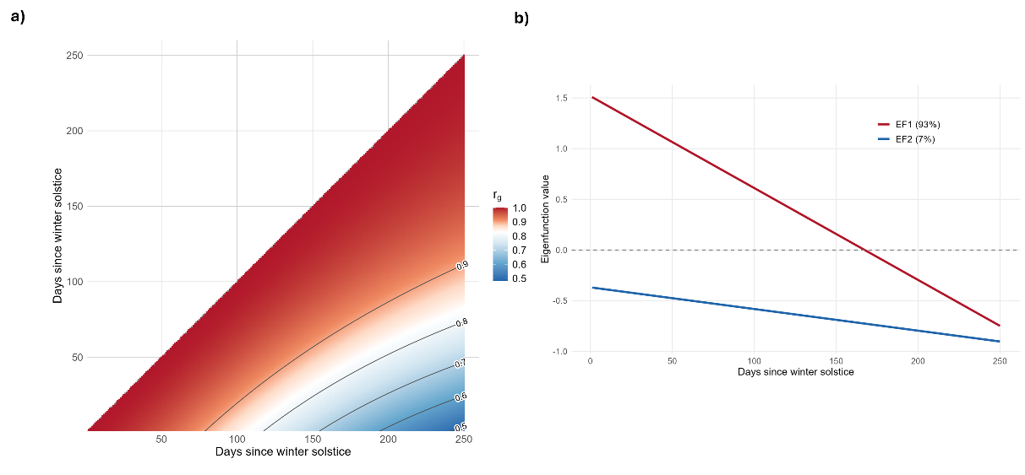
Figure 1. a) Genetic correlations (r_{g}) for yearling fleece shedding across days since winter solstice (DSWS; 0 = 21 June), and b) eigenfunction values of the additive genetic covariance matrix for eigenfunctions 1 and 2 (EF1 and EF2), showing total genetic variance captured.

Eigen decomposition of the additive genetic covariance matrix showed that the first eigenfunction accounted for 93% of the total genetic variance, characterised by a contrast between early and late season shedding scores (Figure 1b). This reflects genetic variation in the rate of fleece shedding across the season rather than overall shedding level, which was captured by the second eigenfunction (7%). Genetic standard deviation increased from 0.58 early in the season to 0.96 at 250 days post-solstice, confirming that genetic differences among animals become increasingly expressed as the season progresses. The genetic correlation between intercept and slope breeding values was 0.60 for EBV with a reportable accuracy of ≥0.52, indicating that animals with superior overall shedding ability also tend to shed more rapidly, though the relationship is not absolute. Comparison of sire intercept and slope breeding values (Figure 2a) showed that many sires clustered in the bottom left quadrant, reflecting superior overall shedding level and rate. However, several sires fell outside this region, demonstrating diversity in shedding trajectories. This is expected as the population has undergone directional selection to improve shedding; however, woollier sires are retained where they have high genetic merit for other traits such as reproduction, as evident in the top right quadrant. Figure 2b shows progeny shedding phenotypes over time. Top-performing sires reached a mean score of 3 by around 125 days post-solstice, while average sires required 100 additional days to reach the same point. This shows that selection on intercept alone would also improve shedding rate, as they are positively correlated (r_{g} = 0.60). However, selecting on both would accelerate progress by avoiding selection of sires in the top left quadrant (Figure 2a).
Outlook. Conventional univariate breeding values remain useful for selection. However, random regression showed that most genetic variation lies in the slope, which univariate evaluations cannot explicitly distinguish. This supports Pollot (2011), who showed that once shedding genes are established in a population, genetic variation is largely driven by the rate and timing of shedding. As recording systems mature, trajectory-based evaluation could improve selection for animals that shed earlier and more completely.
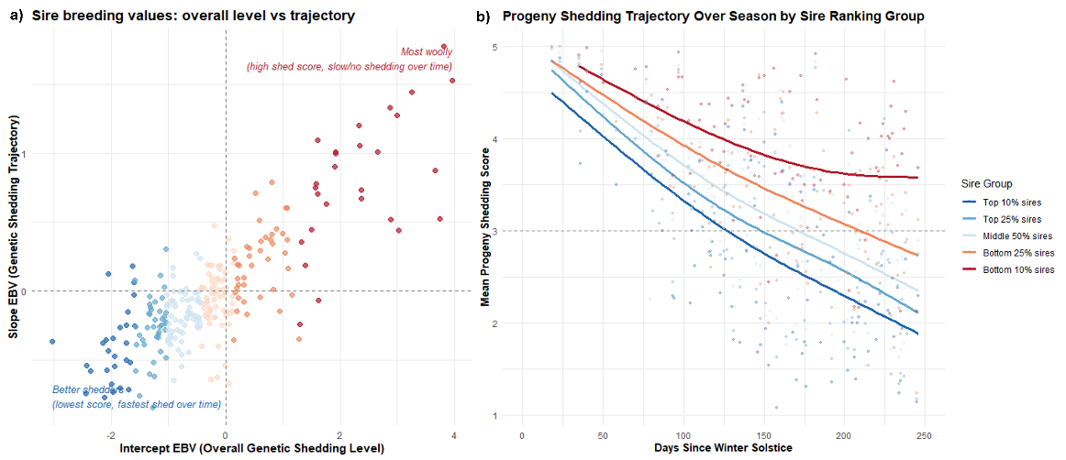
Figure 2. a) Sire EBV for shedding intercept and slope, b) mean progeny shedding score over days since winter solstice grouped by sire intercept percentile bands.

CONCLUSION
Shedding scores recorded later in the season provide greater genetic discrimination among animals. Industry should prioritise recording during peak-to-late season to maximise the accuracy of genetic evaluation. While overall shedding level remains a reliable selection criterion, the slope breeding value offers additional value for identifying animals that shed earlier. Sires with lower intercept and slope breeding values appear to phenotypically produce progeny that shed faster.

ACKNOWLEDGEMENTS
The shedding sheep project (P.PSH.1421) was funded via the Meat and Livestock Australia Donor Company with contributions from Low Footprint Lamb and Cashmore Nudies.

REFERENCES
Lourenco D., Tsuruta S., Aguilar I., Masuda Y., Bermann M., Legarra A., and Misztal I. (2022) Proc. World Congr. Genet. Appl. Livest. Prod. 12: 1530.
Pollot G. (2011) J. Anim. Sci. 89(8): 2316-2325
Sheep Genetics (2025). Sheep Genetics – Score Shedding Sheep.
Smith E.G., Keiller J.R., Kelly M.P., Brown D.J., and Walkom S.F. (2026). Accepted J. Anim. Breed. Genet.

